Tutorial-9

Modules name:OrangeHRM demo
Test Case ID:OrangeHRM demo
Environment Information:os:macos(Sequoria 15.5)system : laptop(macbook air)webpage URL:https://opensource-demo.orangehrmlive.com/web/index.php/auth/login

Screenshort:
Scenario 1:

Demo login page:OrangeHRM demo website opened
Test Steps:1a
1.open the OrangeHRM demo website
2.check the browser on open the page
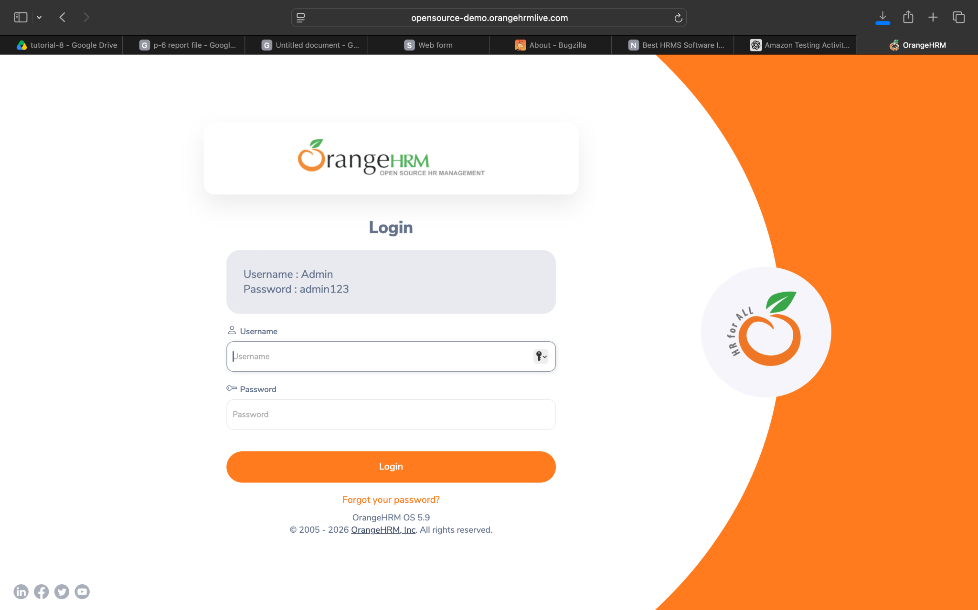
Screenshort:
Scenario 1:

Demo login page:OrangeHRM demo website opened and enter username
Test Steps:1b
1.open the OrangeHRM demo website
2.check the browser on open the page
3.Enter the username

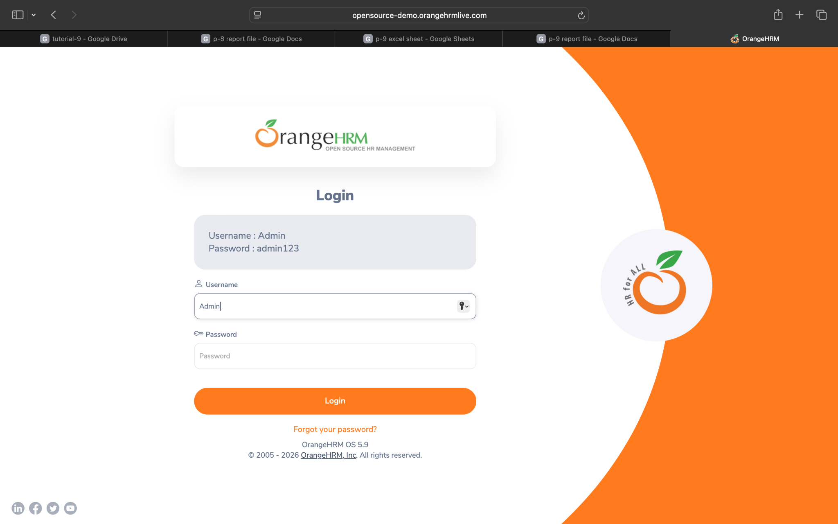
Screenshort:
Scenario 1:

Demo login page:OrangeHRM demo website opened and invalid username
Test Steps:1c
1.open the OrangeHRM demo website
2.check the browser on open the page
3.enter the username
4.displayed the invalid username
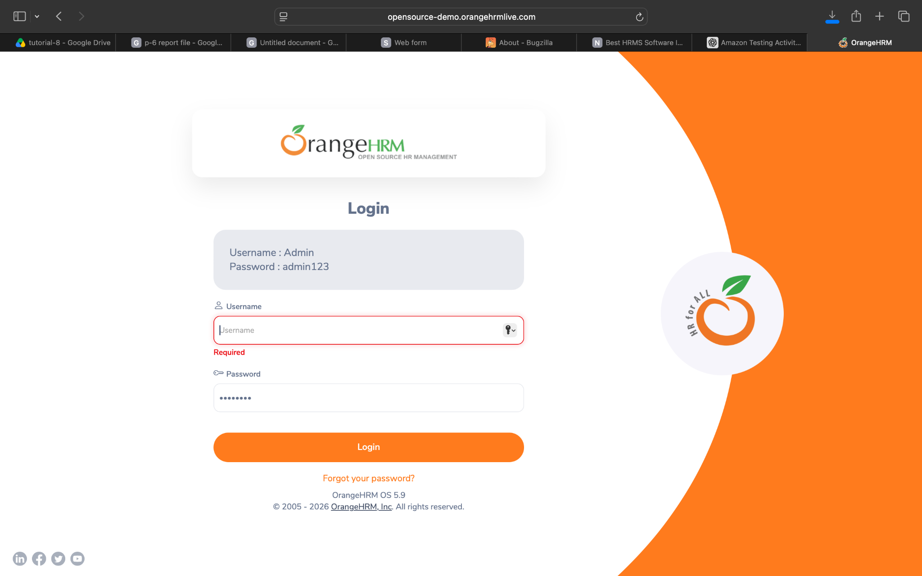
Screenshort:
Scenario 1:

Demo login page:OrangeHRM demo website opened and valid password
Test Steps:1d
1.open the OrangeHRM demo website
2.check the browser on open the page
3.enter the username
4.enter the password

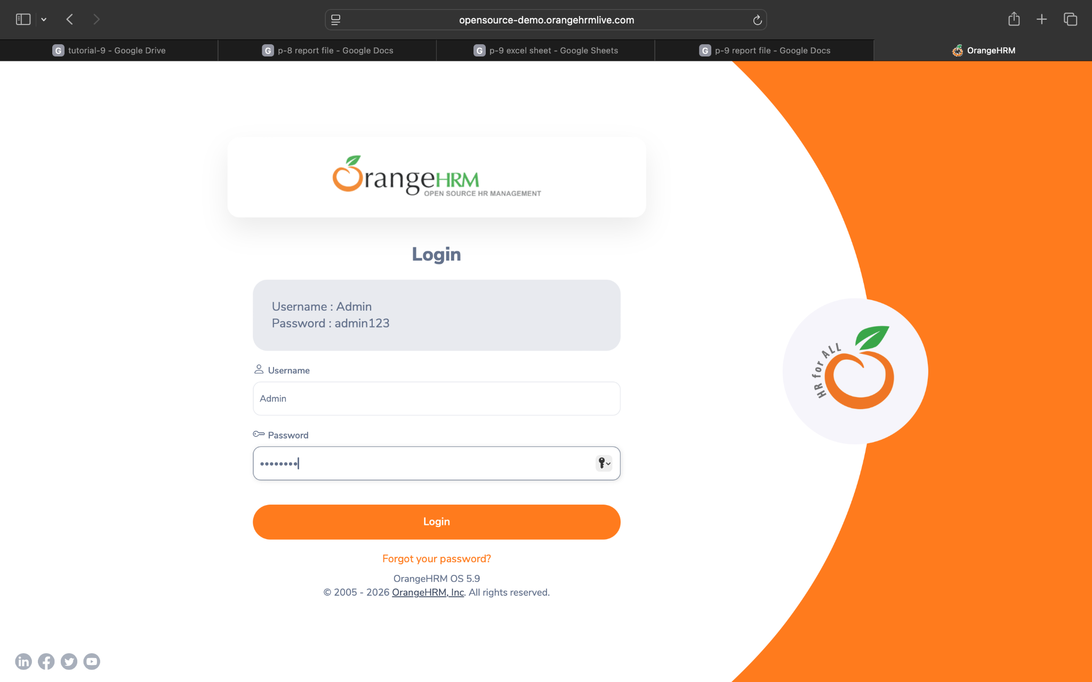

Screenshort:
Scenario 1:

Demo login page:OrangeHRM demo website opened and invalid password
Test Steps:1e
1.open the OrangeHRM demo website
2.check the browser on open the page
3.enter the username
4.enter the password
5.invalid password
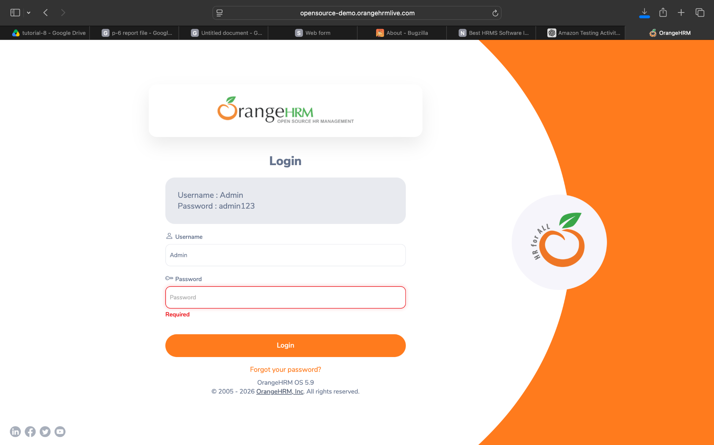

Screenshort:
Scenario 2:

Demo login page:OrangeHRM demo website opened
Test Steps:2a
1.open the OrangeHRM demo website
2.check the browser on open the page
3.enter the username
4.enter the password
5.successfully login the page
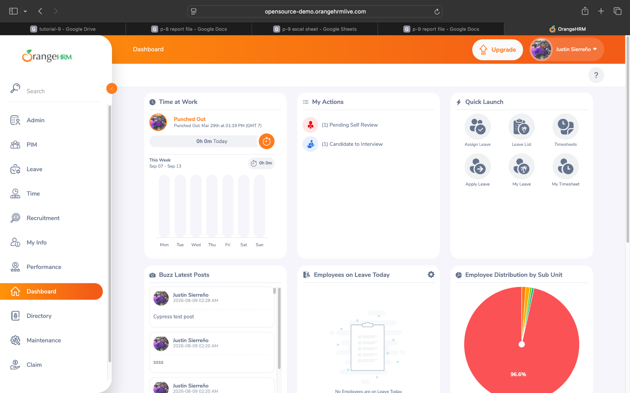

Screenshort:
Scenario 2:

Demo login page:verify the OrangeHRM demo website opened
Test Steps:2b
1.open the OrangeHRM demo website
2.check the browser on open the page
3.enter the username
4.enter the password
5.successfully login the page
6.verify the website

Screenshort:
Scenario 2:

Demo login page:verify the OrangeHRM demo website opened profile
Test Steps:2c
1.open the OrangeHRM demo website
2.check the browser on open the page
3.enter the username
4.enter the password
5.successfully login the page
6.verify the website
7.open the profile page

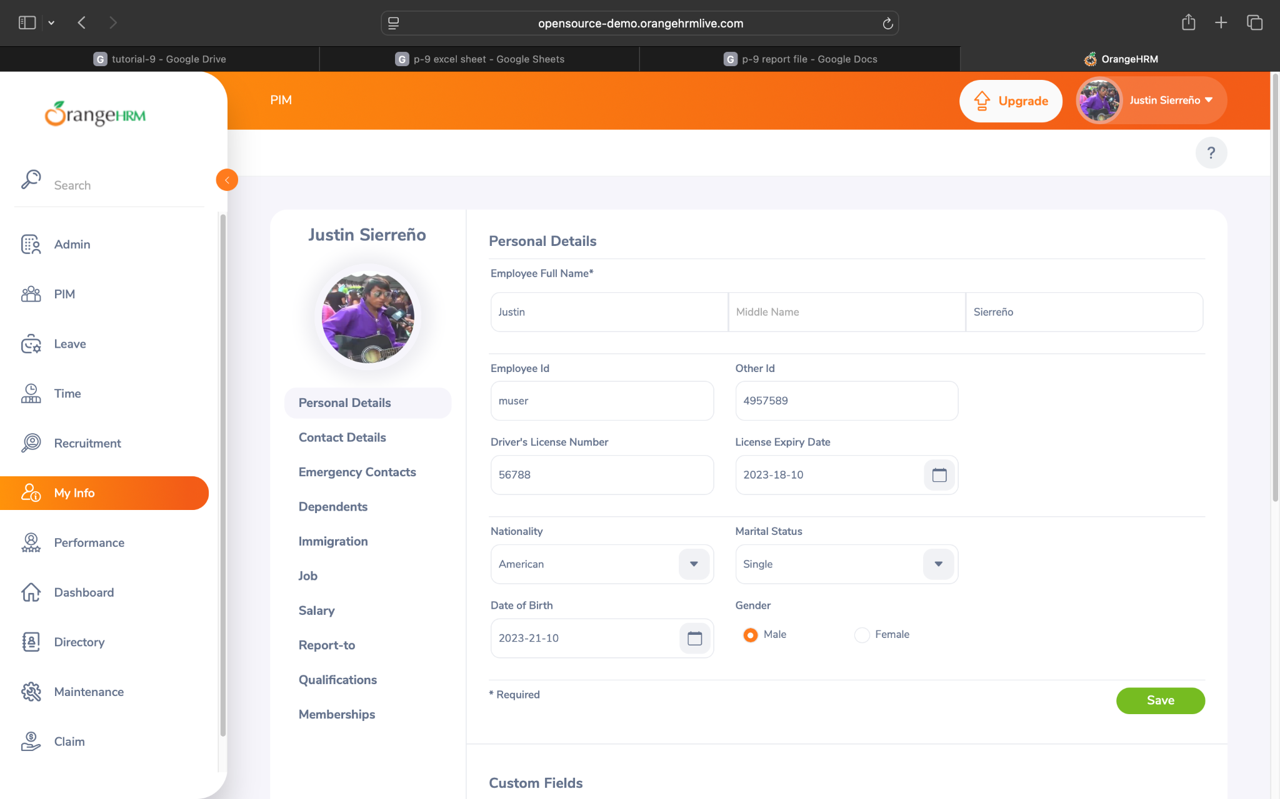

Screenshort:
Scenario 3:

Demo login page:logout the OrangeHRM demo website
Test Steps:3a
1.open the OrangeHRM demo website
2.check the browser on open the page
3.enter the username
4.enter the password
5.successfully login the page
6.verify the website
7.open the profile page
8.logout the account
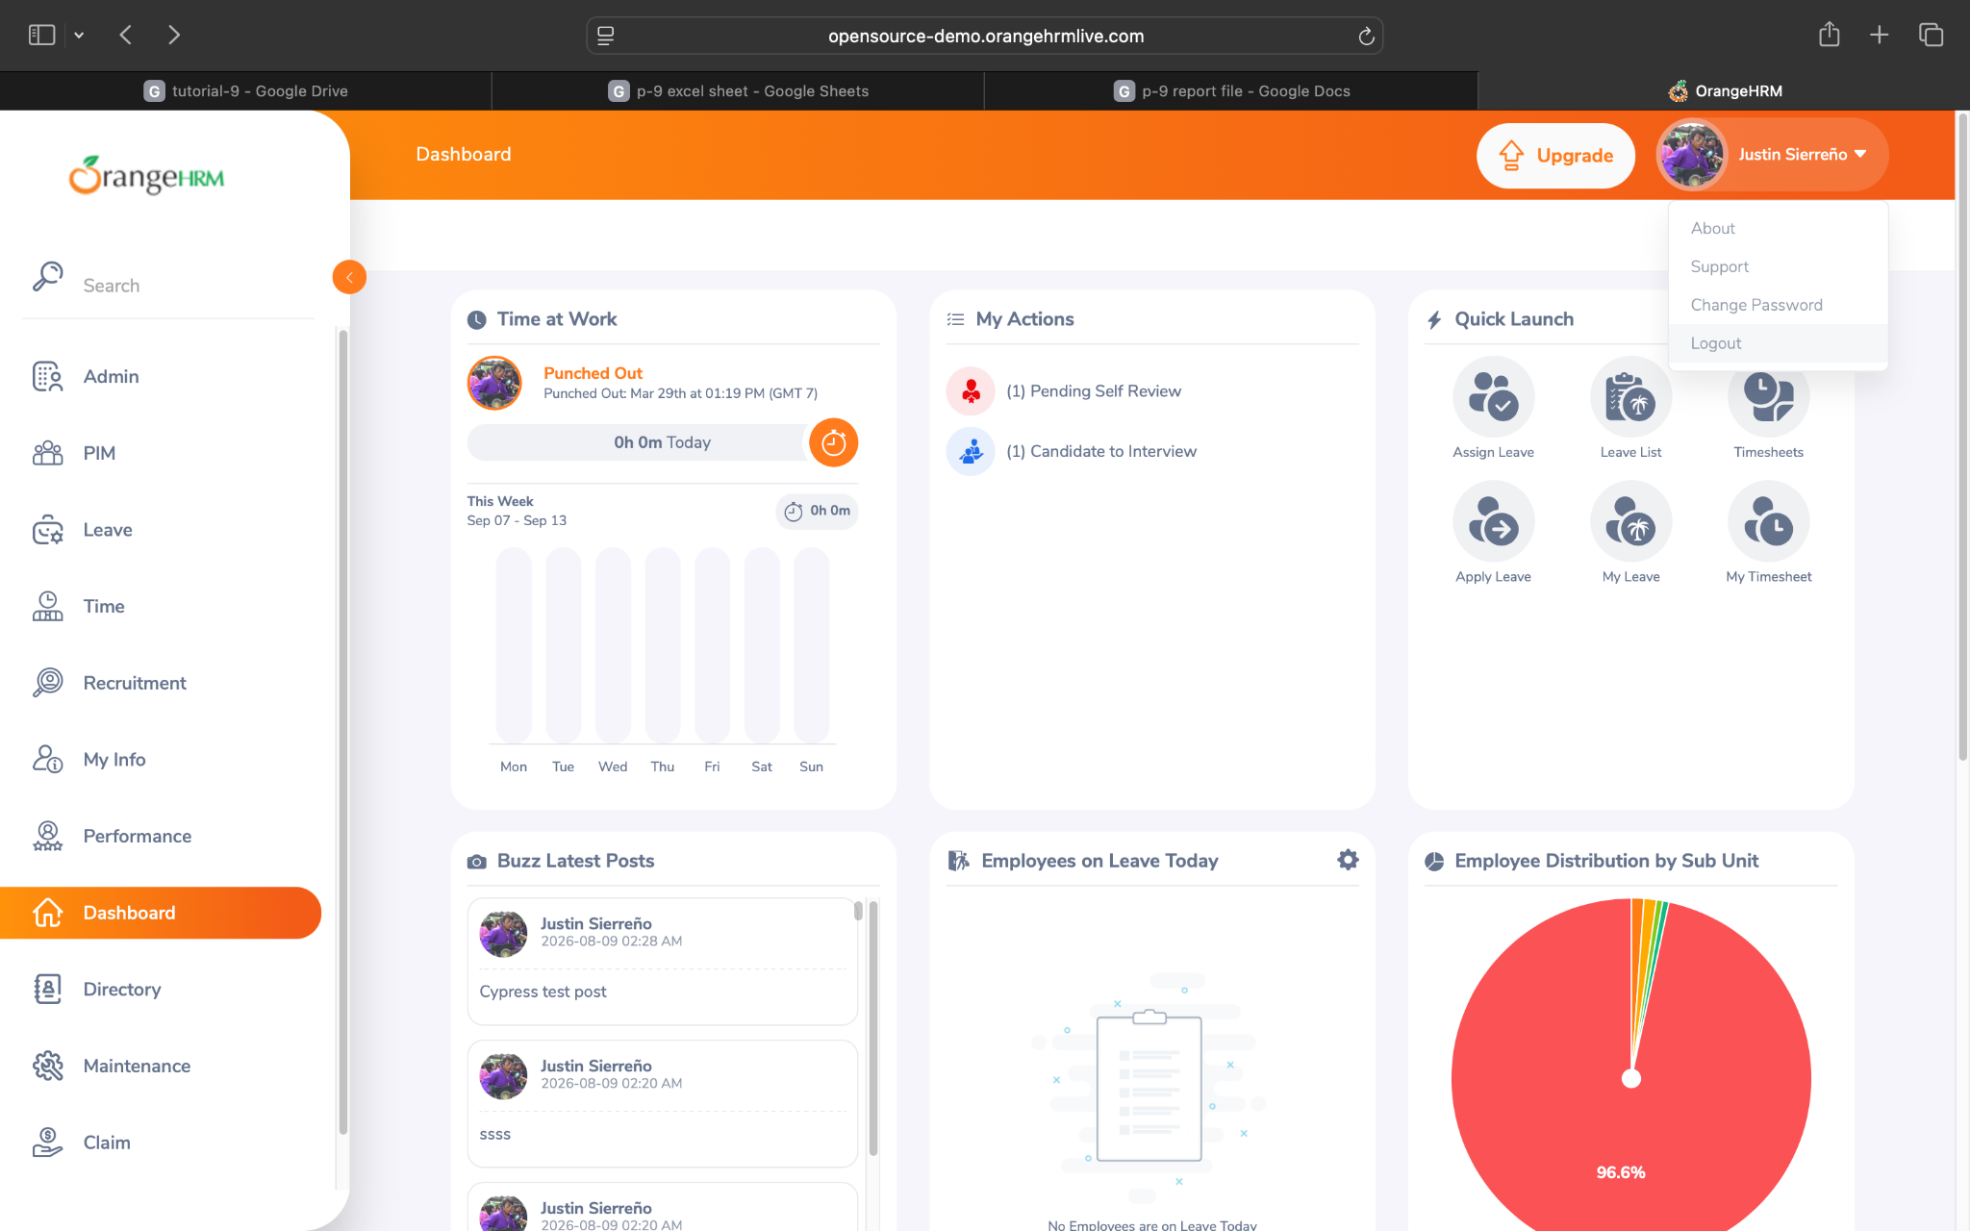

Screenshort:
Scenario 3:

Demo login page: OrangeHRM demo website
Test Steps:3b
1.open the OrangeHRM demo website
2.check the browser on open the page
3.enter the username
4.enter the password
5.successfully login the page
6.verify the website
7.open the profile page
8.logout the account
9.login the page

